

**YEAR: 10**

**SUBJECT: Science**

**Biology 1 & 2 Test**

**ATAR Pathway**

**Please do not mark this paper.**

**Year 10 Biology 1 & 2 Test**

**Part A: Multiple Choice (10 marks)**

**Record answers in the answer booklet provided.**

1. **Which symbols show a cross between a homozygous tall plant and a homozygous small plant**
2. Tt x Tt.
3. TT x tt.
4. Tt x tt.
5. Tt x tt.
6. **Meiosis is a type of cell division that produces**
7. Zygotes.
8. Chromosomes.
9. DNA.
10. Gametes.
11. **The type of inheritance shown when a red-flowering plant is crossed with a white-flowering plant and only pink-flowering plants are produced is**

a) Inbreeding.

b) Polygenic inheritance.

c) Incomplete dominance.

d) Codominance.

1. **If tongue rolling is due to the gene (R) and non-tongue rolling is due to the gene (r) then which of the following crosses could produce a non-tongue roller?**
2. Rr and Rr.
3. RR and RR.
4. RR and rr.
5. RR and Rr.
6. **In tomato plants red (R) fruit colour is dominant over yellow (r) fruit colour. If two hybrid plants (Rr) and (Rr) were crossed, the most likely ratio of fruit colour would be**
7. 1 red : 1 yellow.
8. 2 red : 2 orange : 1 yellow.
9. 1 red : 3 yellow.
10. 3 red : 1 yellow.
11. **The table to the right shows the order of amino acids present in a protein from five different**

**organisms. Based on this evidence, a researcher could conclude that the two closest relatives**

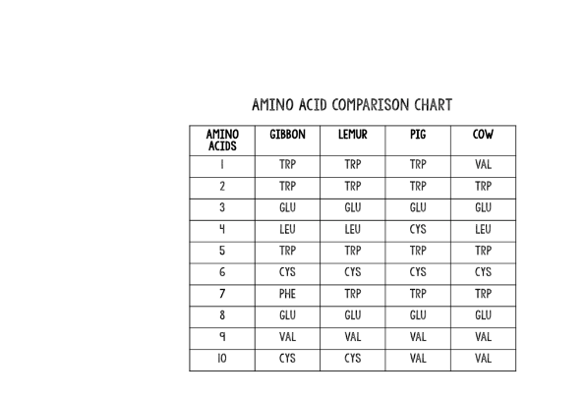 **are**

* 1. Lemurs and gibbons.
  2. Lemurs and pigs.
  3. Cows and pigs.
  4. None of the above. Amino acids cannot be used to

determine relatedness.

1. **A population of bacteria is treated with hand sanitizer. Because of genetic variation in the population, what is a possible outcome?**
   1. The population will grow quickly.
   2. All of the bacteria are already resistant.
   3. They will get better at obtaining a food source.
   4. Some may be resistant and survive.

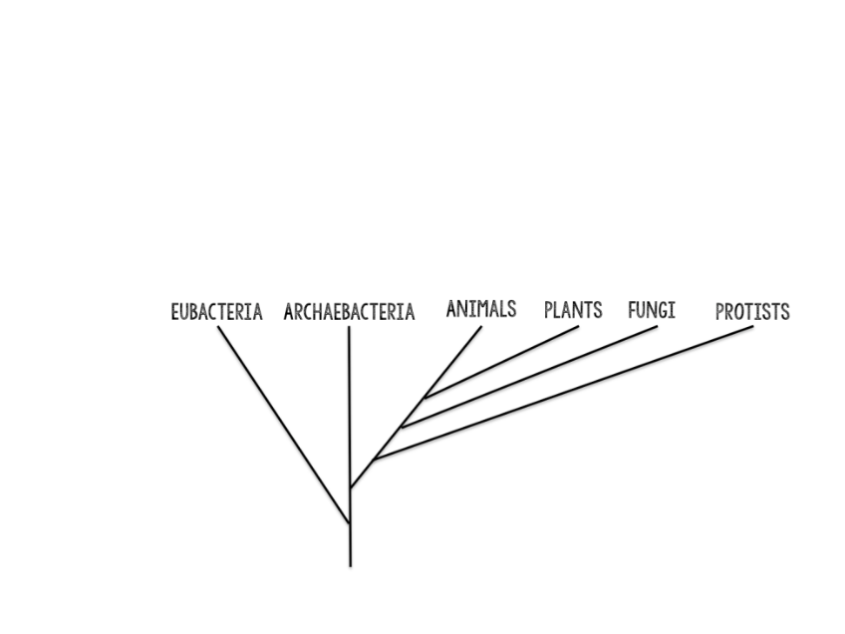

**8. According to the phylogenetic tree**

* 1. an ancestor of eubacteria gave rise to all life on earth.
  2. archaebacteria came from eubacteria.
  3. animals gave rise to plants and fungi.
  4. eubacteria and archaebacteria have no common ancestor.

1. **Which of the following is NOT required for speciation to occur?**
2. Environmental resistance.
3. Variation.
4. Genetic isolation.
5. Selection pressure.
6. **Charles Darwin was famous for**
7. defining the term evolution.
8. suggesting natural selection was the mechanism of evolution.
9. writing a book called ‘The Origin of Species’ that showed how natural selection resulted from evolution.
10. inventing the term artificial selection and proposing that it caused evolution.



**Biology 1 & 2 Test**

**ATAR Pathway**

**ANSWER BOOKLET**

**NAME:**

**CLASS: DATE:**

**ASSESSMENT KEY**

|  |  |
| --- | --- |
| **I CAN STATEMENTS** | **QUESTIONS** |
| **MUST**  Explains the influences of competition and variation on natural selection. | 1, 2, 3, 8, 9, 10, 11, 12, 13, 15, 17,18, 19, 20, 22 |
| **SHOULD**  Explains evolution in a population, describing the influences of variation which support survival and lead to natural selection. | 4, 6, 7, 14, 21, 22 |
| **COULD**  Explains evolution in a population, correctly outlining the influences of heredity, describing the sources of variation which support survival and lead to natural selection and changes in the gene. **pool** | 5, 16, 22 |

**Multiple Choice Short Answer Extended Answer Total**

**/49**

**/9**

**/30**

**/10**

**SECTION ONE: Multiple choice answers**

**Cross (X) through the correct answer.**

|  |  |  |  |  |
| --- | --- | --- | --- | --- |
| **1** | **a** | **b** | **c** | **d** |
| **2** | **a** | **b** | **c** | **d** |
| **3** | **a** | **b** | **c** | **d** |
| **4** | **a** | **b** | **c** | **d** |
| **5** | **a** | **b** | **c** | **d** |
| **6** | **a** | **b** | **c** | **d** |
| **7** | **a** | **b** | **c** | **d** |
| **8** | **a** | **b** | **c** | **d** |
| **9** | **a** | **b** | **c** | **d** |
| **10** | **a** | **b** | **c** | **d** |

**Part B: Short Answer (30 marks)**

1. Select the correct term from the list below and write it in the box next to its description. (3 marks)

allele dominant gene genotype

homozygous phenotype recessive heterozygous

|  |  |
| --- | --- |
| **Term** | **Description** |
|  | A form of a gene that always has its effect when it is present. |
|  | A form of a gene that codes for one of a pair of contrasting features. |
|  | The alleles that an organism has in its chromosomes. |

1. The diagram below shows a simplified illustration of the stages of meiosis.

However, the stages are not in the correct order.

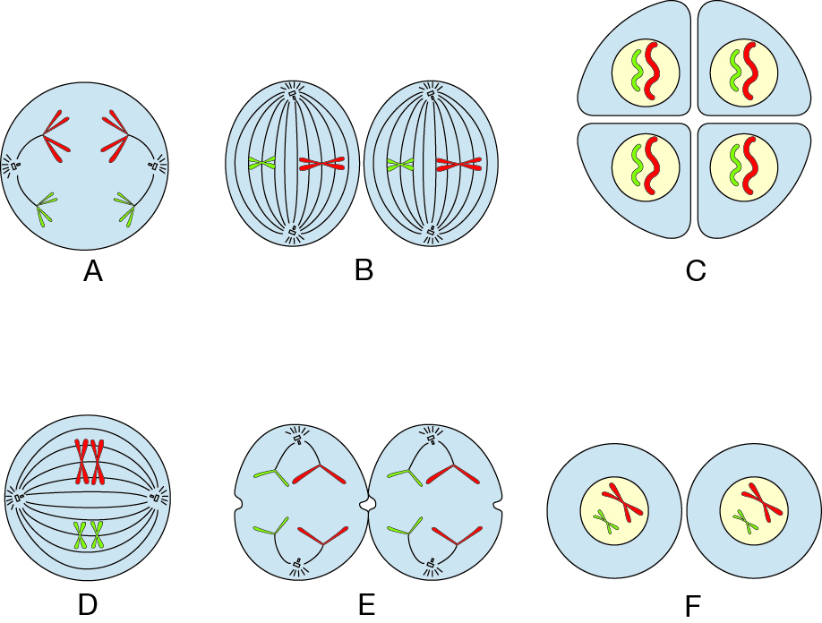

a) Identify the correct order and write the letters corresponding to each stage in order.

_________________________________________________________________ (3 marks)

b) How many cells form at the end of meiosis and how many chromosomes do they each

contain?

Number of cells _____________ (1/2 mark) Number of chromosomes ____________(1/2 mark)

1. 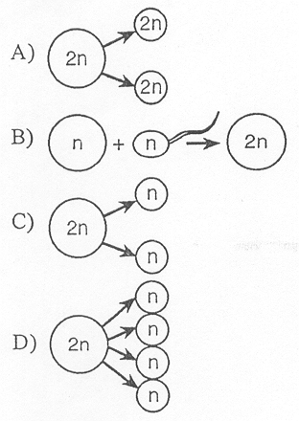Use the diagram below to answer the following questions: (2 marks)
2. Which letter represents meiosis? _________________________
3. Which letter represents mitosis? _________________________
4. Which letter represents fertilisation? ______________________
5. What is the ultimate goal of mitosis? _______________________
6. A red cow and a white cow were crossed and produced a roan cow (red and white hairs).

Using the symbols R and W, construct a genetic diagram and explain the results of this cross.

(1 mark)

|  |  |  |
| --- | --- | --- |
|  |  |  |
|  |  |  |
|  |  |  |

Explanation of the results: (2 marks)

______________________________________________________________________________

______________________________________________________________________________

______________________________________________________________________________

1. Match the vocabulary word with the proper definition. (3 marks)

**Terms**

Artificial selection Evolution Wallace Natural selection Darwin Fitness

**Definitions**

_____________ Change in species over time

_____________ One of the first scientists to propose that species change over time

_____________ Developed a theory of evolution at the same time as Darwin

_____________ An organism’s relative ability to survive and produce fertile offspring

_____________ The process by which evolution occurs

_____________ Selecting for plants and animals with useful traits

1. Haemophilia is an X-linked recessive disease. The symbol XH is used to show the normal gene on

the X chromosome, and the symbol Xh is used to show the recessive gene on the X chromosome.

1. State the possible genotypes of a:

i) haemophiliac male _________________ (1/2 mark)

ii) non-haemophiliac female ______________ (1/2 mark)

1. A female may be a ‘carrier’ of the disease.

i) Clarify what is meant by the term ‘carrier’ make reference to the above example. (2 marks)

_____________________________________________________________________________

_____________________________________________________________________________

1. **Explain** why variation is necessary **before** natural selection can occur. (2 marks)

*In order for natural selection to work, why can’t all the individuals in a population look the same?*

______________________________________________________________________________

______________________________________________________________________________

1. Use the diagram below to answer the following questions.

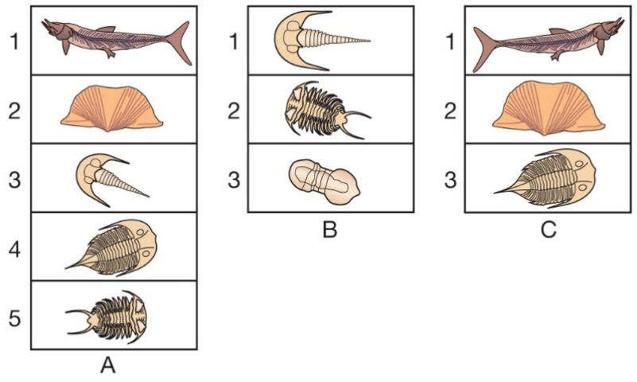

1. **Identify** the oldest strata over the three sites (give site and layer number). (1 mark)

___________________________________________________________________

1. **Identify** the youngest strata in the three sites. (1 mark)

___________________________________________________________________

1. **Identify** a layer from site A that you would expect to be found at site B, but which did not occur here. (1 mark)

___________________________________________________________________

1. **List** one structural and one physiological adaptation of Aboriginal and Torres Strait Islander peoples to the environment. (1 mark)

________________________________________________________________________________________________________________________________________________________________________________________________________________________________________________________________________________________________________________________

1. Male peafowl, called peacocks, have long, colourful tail feathers. Among peacocks there is variation in the size, brightness, and pattern of the tail. Scientists observed the mating success of two groups of peacocks. The graph below shows the scientists’ data.

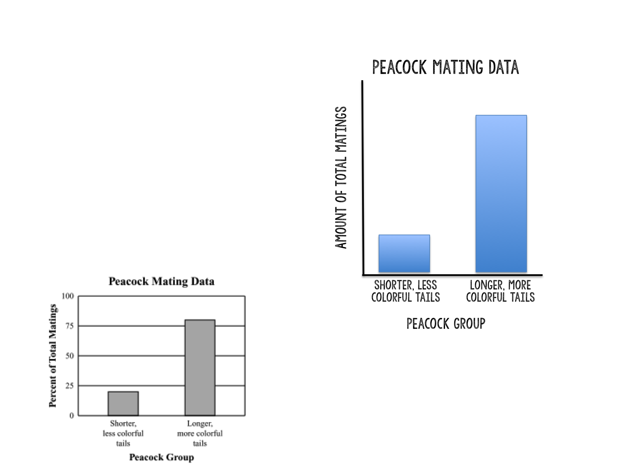

* 1. **Explain** what the graph shows about the advantage of longer, more colourful tails for peacocks. (1 mark)

______________________________________________________________________________

* 1. Identify **one** disadvantage that longer, more colourful tails may have for peacock.

(1 mark)

______________________________________________________________________________

1. In the peppered moth population in England, which came first, the gene controlling dark colour, or the darkening of the environment through pollution? Explain (2 marks)

______________________________________________________________________________________________________________________________________________________________________________________________________________________________________________________________________________________________________________________________________________________________________________________________________

1. How did the Industrial Revolution affect the peppered moth population? (2 marks)

______________________________________________________________________________________________________________________________________________________________________________________________________________________________________________________________________________________________________________________________________________________________________________________________________

**Part C: Extended answer** **(9 marks)**

1. **Identify** three forms of evidence for evolution and describe how they support the theory that all organisms share a common ancestor. Ensure that you include an **example** for each source of evidence.

________________________________________________________________________________________________________________________________________________________________________________________________________________________________________________________________________________________________________________________________________________________________________________________________________________________________________________________________________________________________________________________________________________________________________________

________________________________________________________________________________________________________________________________________________________________________________________________________________________________________________________________________________________________________________________________________________________________________________________________________________________________________________________________________________________________________________________________________________________________________________________________________________________________________________________________________________________________________________________________________________________________________________________________________________________________________________________________________________________________________________________________________________________________________________________________________________________________________________________________________________________________________________________________________________________________________________________________________________________________________________________________________________________________________________________________________________________________________________________________________________________________________________________________________________________________________________________________________________________________________________________________________________________________________________________________________________________________________________________________________________________________________________________________________________________________________________________________________________________________________________________________________________________________________________________________________________________________________________________________________________________________________________________________________________________________________________________________________________________________________________________________________________________________________________________________________________________________________________________________________________________________________________________________________________________________________________________________________________________________________________________________________________________________________________________________________________________________________________________________________________________________________________________________________________________________________________________________________________________________________________________________________________________________________________________________________________________________________________________________________________________________________________________________________________________________________________________________________________________________________________

**End of test. Please edit your work prior to submission.**